**The goal of this assignment is to learn more basic functions of Adobe XD**

1. Please create Wireframe by following the steps here <https://webdesign.tutsplus.com/tutorials/how-to-start-wireframing-with-adobe-experience-design-xd--cms-31185>

Your wireframe does not have to be exactly the same as on the above page

2. After finishing your wireframes, click “Prototype” on the top

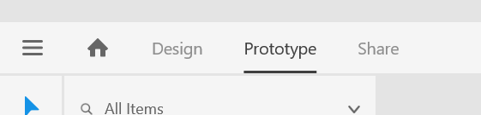

3. Click the “Sign in” button on the first artboard, and then drag the arrow to be connected to the second artboard

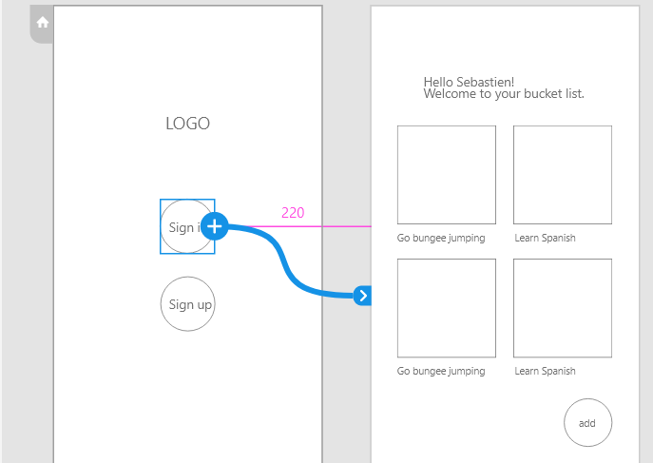

4. Click the “add” button on the second artboard, and then drag the arrow to be connected to the third artboard

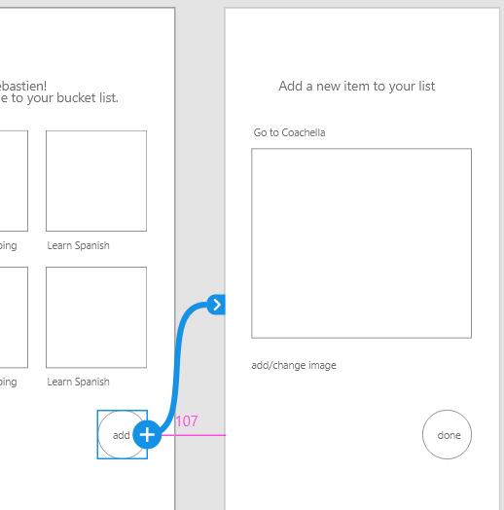

5. Click the “done” button on the third artboard, and then drag the arrow to be connected to the second artboard

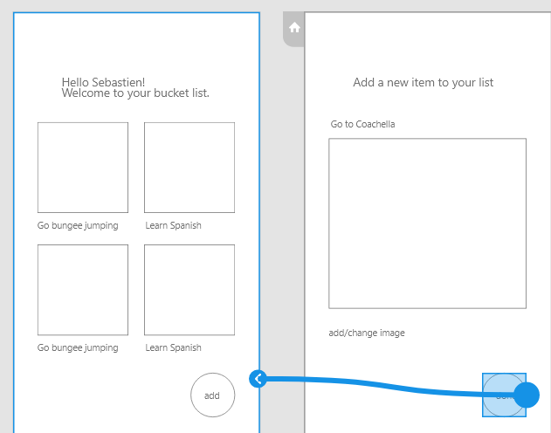

6. click the preview button in the top-right corner

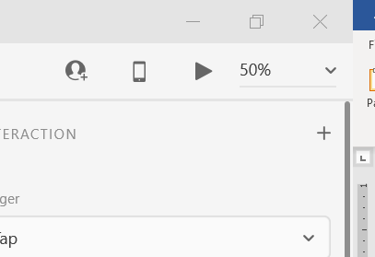

Click on the buttons to see how to navigate to different pages

7. Click “Share” in the top-left corner, give your design a name, and create a link. Please do not require a password

Please save your design and submit your .xd file to individual assignment 2 on Reggienet and also submit your sharing link

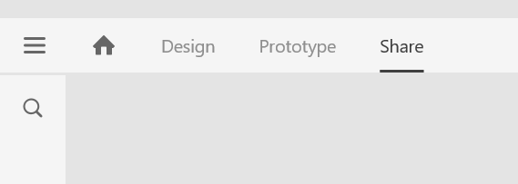 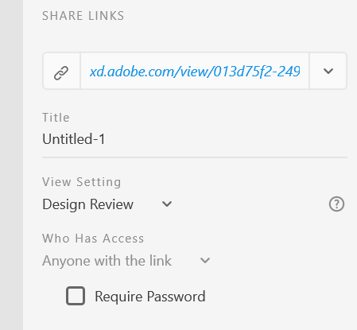

Solution: **Please see:-**

<https://xd.adobe.com/view/db07e698-a7fe-4fcc-afd1-3198022c584e-8e54/>